SUMMER TRAINING REPORT ON

GOLDVISOR(SALESFORCE)

2019-2020

Training Held At
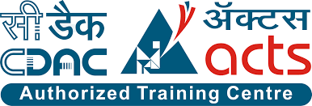

NETPARAM TECHNOLOGIES PVT. LTD

IT-Division of C-DAC

Submitted By:-

RAHUL AGARWAL

TAVISHI SOLET

INDEX-

Introduction
- What Is Gold Loan System?

What is Salesforce?

Some Important Salesforce Concepts

About The Project

Conclusion

Literature Survey

INTRODUCTION
- “GOLDVISOR” as the name suggests is a platform which is a financial advisor for the gold loans.Once the application is submitted, a gold loan agreement is signed between the customer and bank.
- Next, the gold that has been valued is deposited with the bank for disbursal of loan.
The bank keeps custody of gold till loan is repaid.
Loans typically have tenure of 12 to 18 months.
- The “GOLDVISOR APP” is a centralized system which records and maintains customer, loan, employee and branch details.
- This app is a one stop solution for all the processes and needs of the gold loan company.
- The ups and downs in the gold rates is also shown in this app.

What is Gold Loan System?
India is one of the largest consumers of gold in the world. As per the World Gold Council (WGC), the annual gold demand in India from 1987 until 2016 has increased by 804%. And the trend does not seem to die anytime soon. The precious metal other than being used for industrial, commercial and investment purposes can also be used to get a loan at the time of a financial emergency. In fact, the gold loan is one of the easiest and fastest ways to access funds when it matters the most.
Even if you have a low credit score but ample amounts of idle gold in your locker, the gold loan can be the monetary solution for you. With the growing popularity of gold loan every year, it is important to know not only what gold loan is but also how it works, gold loan interest rates, and other related details.

What is a gold loan?
The gold loan, also referred as a loan against gold, is a secured loan that a borrower takes from a lender in lieu of gold ornaments such as gold jewelry. The loan amount sanctioned to you by lenders is generally a certain percentage of the gold’s value. You can repay it through monthly installment after which you get your gold articles back. Unlike other secured loans such as a home loan or car loan, there are no restrictions on the end use of gold loans. So whether you need to fund a wedding, family vacation or your child’s education, it is a great way to meet your sudden money requirement. Moreover, a lot of private and nationalised banks along with NBFCs offer gold loans at affordable interest rates.

How does gold loan works?
The entire process of gold loan is quite similar to other secured loans. In this, you take your gold articles to a lender along with the required set of documents. The lender evaluates the gold articles and verifies the submitted documents. As per the evaluations, the lender sanctions the loan amount. As per the loan agreement, you pay off the principal amount along with the interest amount and get the pledged gold articles back.

Who is eligible to apply for a gold loan?
Anyone who has gold can get a gold loan. Unlike personal loans, which include stringent eligibility criteria, gold loans can be availed by any Indian resident, which can include salaried professionals, businessmen, housewives, and even farmers. You don’t even need to have a good credit score to be eligible for a gold loan. So if you have a low credit score, you still have a chance to get funds, provided you have enough gold to pledge for it.

What is the interest rate on which lenders give the gold loan?
Gold loan is a secured loan; therefore, its interest rate is low in comparison to unsecured loans such as a personal loan. The interest rates levied on gold loan varies from one lender to another and depends on various factors such as gold loan tenure, loan amount, etc. It also relies on where you are taking the gold loan – a bank or an NBFC? Banks usually charge lower gold loan interest rate than NBFCs. Therefore, if you are planning to apply for the gold loan, do not accept the first offer you get. Compare gold loan offers from at least two to three lending institutions and then make your choice.

What is the gold loan tenure?
The prepayment period or gold loan tenure varies from one lending institution to another. It usually ranges from 3 to 12 months. Depending on a case, some lenders even offer a longer tenure or allow you to renew it in order to extend the tenure. Since the tenure of the gold loan is shorter in comparison with other types of loan, make sure you repay the loan amount on time. Defaulting on gold can lead to losing your gold articles forever.

How do lenders determine the gold loan amount?
Before approving the loan application, lenders evaluate the pledged gold’s purity and weight. Based on it, the gold’s market value is determined based on its current rate, which further helps in reaching the final gold amount that is to be sanctioned by lenders. Most lenders offer a gold loan with a value up to 75 percent of the pledged gold’s market value. For instance, if your gold is worth 2 lakhs, the loan amount sanctioned to you would be not more than 1.5 lakhs. Besides the Loan to value ratio, loan amount also depends on various other factors such as tenure and the borrower’s repayment capacity.

How can the gold loan be repaid?
How you can repay your gold loan depends on your lender. Most lending institutions let you pay only the interest amount each month and the principal amount at the end of the loan tenure. You can also choose to pay your gold loan through EMIs (Equated Monthly Installments), which will include both the principal and interest component of your loan.

WHAT IS SALESFORCE?
Salesforce.com, Inc. (usually abbreviated as SF or SFDC) is an American cloud-based software company headquartered in San Francisco, California. Though the bulk of its revenue comes from its customer-relationship management (CRM) service, Salesforce training also sells a complementary suite of enterprise applications focused on customer service, marketing automation, analytics and application development.
Salesforce was ranked first in Fortune's 100 Best Companies to Work For in 2018.

Salesforce
Salesforce is the primary enterprise offering within the Salesforce platform. It provides companies with an interface for case management and task management, and a system for automatically routing and escalating important events. The Salesforce customer portal provides customers the ability to track their own cases, includes a social networking plug-inthat enables the user to join the conversation about their company on social networking Web sites, provides analytical tools and other services including email alert, Google search, and access to customers' entitlement and contracts.

Lightning Platform
Lightning Platform (also known as Force.com) is a platform as a service (PaaS) that allows developers to create add-on applications that integrate into the main Salesforce.com application. These third-party applications are hosted on Salesforce.com's infrastructure.
Force.com applications are built using declarative tools, backed by Lightning and Apex (a proprietary Java-like programming language for Force.com)and Lightning and Visualforce (a framework that includes an XML syntax typically used to generate HTML). The Force.com platform typically receives three complete releases a year.As the platform is provided as a service to its developers, every single development instance also receives all these updates.
In the Spring 2015 release a new framework for building user interfaces – Lightning Components – was introduced in beta. Lightning components are built using the open-source Aura Framework but with support for Apex as the server-side language instead of Aura's Javascript dependency. This has been described as an alternative to, not necessarily a replacement for, Visualforce pages.
According to a September 2009 Gartner Group report,Force.com had over 1,000 customer accounts. As of 2013, the Force.com platform has 1.4 million registered developers.

Community Cloud
Community Cloud provides Salesforce customers the ability to create online web properties for external collaboration, customer service, channel sales, and other custom portals in their instance of Salesforce. Tightly integrated to Sales Cloud, Service Cloud, and App Cloud, Community Cloud can be quickly customized to provide a wide variety of web properties.

Work.com
Work.com, previously Rypple, is a social performance management platform that helps managers and employees improve work performance through continuous coaching, real-time feedback, and recognition.It is marketed as a solution for sales performance, customer service, marketing, and as a service that can be employed by human resource departments.
Work.com, then known as "Rypple", was founded by Daniel Debow and David Stein, who wanted to create a simple way of asking for feedback anonymously at work. The company was formed in May 2008 and their client list included Mozilla, Facebook, LinkedIn and the Gilt Groupe. Rypple "'reverses the onus on the demand for more feedback' by getting employees to build and manage their own coaching networks".
In September 2011, Rypple announced that they had hired Bohdan Zabawskyj as its Chief Technology Officer.
In 2011, Rypple developed a more formalized management methodology called OKR ("Objectives and Key Results") for Spotify.Rypple also partnered with Facebook to create "Loops", short for "feedback loops", which gathers feedback from co-workers, "thank you's", progress against goals, and coaching from supervisors into one channel for a "rich, robust, continuous performance review".
In December 2011, Salesforce.com announced that they would acquire Rypple. The transaction was completed in 2012 and Rypple was rebranded as Work.com in September 2012.

AppExchange
Launched in 2005, the Salesforce AppExchange is an online application marketplace for third-party applications that run on the Force.com platform. Applications are available for free, as well as via yearly or monthly subscription models. Applications available range from integrations with SharePoint to mobile approval management.[39] As of June 2016, it features 2,948 applications which have driven 3+ million installs.[40] The "AppExchange" is also a place customers can search for cloud consulting partners to help them implement the technology in their own organization. Cloud consulting partners for Salesforce include large companies like IBM's "Bluewolf" and Accenture as well as smaller ones like Cloudreach.

myTrailhead

Announced in 2017 and launched in 2019, Salesforce's myTrailhead is an online training platform that can be customized for the specific needs of its customers. The platform extends functionality which Salesforce built to provide users with training content specific to their usage of Salesforce and enables users to create and publish their own training content and programs.

Blockchain platform
Announced on May 29, 2019,Salesforce launched a blockchain platform to facilitate building blockchain network and apps integrated with CRM.

SALESFORCE CONCEPTS

What is an Application in Salesforce?
App means Application. Application is a collection of components with you tabs, reports, dashboards, Vf pages and so on.

Types of Applications in SFDC.
In Salesforce.com, we have two types of Applications they are
- Classic Apps and
- Lightning Apps.
In Salesforce we can create, manage and Customise both application according to user requirement.

What is an Object?
Every object will have a field and a record. Force.com database is like a relational database table which stores a certain type of information in its field and records. In Salesforce Objects, Fields are corresponded as Columns and records are corresponded as Rows.

Different Types of Objects in Salesforce
In Salesforce, Objects are of two they are Standard Objects and Custom Objects.

Standard Objects

In Salesforce, Standard Objects are the one which are created by Salesforce.com by default. Example:- Chatters, campaign, Leads, Contacts, Opportunities and so on.

Custom Objects
In Salesforce, Custom objects are those which are created by Salesforce user and the API name is suffixed with __C

Salesforce Object relationships

Salesforce Object relationships is nothing but a two way association between two Objects. One Object record information is linked in another object record. In Salesforce.com, Object Relationships is created between two Object. Here the custom field of an Object record contains a link in another object record. To build many custom object in Salesforce.com, relationships plays a major role.
In Salesforce.com, Relationships are used to fetch data from other object records. Here the parent ID is stored in pre-defined relationship.

Types of Salesforce Object Relationships.
The Salesforce object Relationships can be divided in to Two types. They are
- One to Many (1:M) :- One parent record is associated to many child records. Basically it forms the parent-child relationships. A parent object can have many child’s objects but a child object must have only one parent object.
  - Master-Detail Relationship:-
  - Lookup Relationship.
- Many to Many (M:M).

Master-Detail Relationship in Salesforce.
- Master-Detail relationship is a one type of relationship which form tight bond relationship between Parent object and Child object.
- Child records should always associated to a parent they can not remain orphan.
- Cascade record deletions. When a parent object record is deleted all it’s child records get deleted automatically.
- Standard Objects cannot be a detail object(Child object). ex: Account cannot be detail object.
- The master-detail relationship fields is required on the page layouts of the detail object.
- Roll-up Summary fields can be created on Master object(Parent Object.)
- Child record inherits all security and sharing settings from it’s parent record.

Lookup Relationship in Salesforce.
- Lookup relationship is a one type of relationship which form loose bond relationship between Parent object and Child object.
- In lookup Child record need not be associated to a parent.
- No Cascade record deletion happens.
- Lookup field is not required on the page layouts of the detail object.
- No Rollup summary fields can be created in Lookup relationship.
- Doe’s not inherit any settings from it’s parent record.
Many to Many Relationship in Salesforce.
One record of One object is linked to multiple records of another object and vice versa. In Salesforce.com, We create Many-to-Many Relationship by creating two master-details relationship with a common Junction Object.
What is Junction Object in Salesforce?
In Salesforce, Junction Object is custom object which is use to link one instance of a record to many child records and many child records to on records equally.
Example:- The relationship between a company and a Customer is many to many relationship because a company can sell a product to multiple customers and a customer can purchase a product from multiple companies.

What is Salesforce Schema Builder?
Schema builder salesforce is a pictorial representation of all objects, fields and their relationships in Salesforce.com.It provides a dynamic environment to view and modify all the objects and their relationships.

What is a Formula Field in Salesforce?
Formula Field is a custom field generated by system of data type Formula. It is a read-only field which means we can not edit Formula Field.
- Formula Field in a read-only field.
- Formula Field derives the value from Formula expression.
- When the source field get changed automatically the Formula field changes(Updated).
- Formula in Salesforce are used to calculate custom fields, validation rules, Flow logic etc.
- Using Formula Editor we create formula in Salesforce.

What is a Validation Rule?
Validation rules in Salesforce are the rules which contains a formula expressions that validates our data and returns a value of “True” or “False.
- Validation rule contain Formula expressions.
- It evaluate the data entered by the user.
- Validation Rule displays error message to user when the enter invalid values.
- We can create Validation rules in Salesforce for Objects, fields, campaign members etc.
Examples of validation Rules.
- Quantity cannot be Negative.
- A field to hold only certain values.
- Zip code, phone number to entered in certain format

What is Rollup Summary field?
Rollup Summary field is a read only field which is used to calculate the count of child records, Sum, Minimum, Maximum of a field on the child object. It is enable for master inMaster – Detail Relationship.
- Roll-Up Summary field means working on the child object.
- Rolling up the child records and computing the value on the Parent record.
- Rollup Summary Field can not be created in lookup relationship.
- Using Apex Trigger we can create Rollup Summary field in Lookup relationship.

Field Dependencies in Salesforce
Field Dependencies in Salesforce are the filters that allow user to change the contents of a picklist based on the value of another field.
Example :- Here there are two field called Country and State. We have to display all states that are related to Country Field. Like wise Districts that are related to States. Here one field is dependent on another field.
In Field Dependencies, we have to learn about two fields they are
- Controlling Field.
- Dependent field.

Role Hierarchies in Salesforce
Role hierarchies in Salesforce are sharing settings at application level. Role hierarchies and sharing settings in Salesforce determines the level of visibility that users and its subordinates to access object records.

Salesforce Security – Field Level Security
Field Level Security settings in Salesforce give permissions at object level to administrators restrict user’s access to view and edit some certain fields. The fields that users see on detail and edit pages are a combination of page layouts and field level security settings.

Profiles and Permission Sets in Salesforce
In this Salesforce admin Tutorial we are going to learn about What is Permission Set, How to assign permission sets to users and Difference between Profiles and Permission Sets in Salesforce.

What Is Permission Set?
Permission Sets in Salesforce extends user’s functional access without changing their profile. It is a collection of Settings and permissions.

Salesforce Workflow Rules

Salesforce Workflow Rules are the automated process used in business process to send Email alerts, assign a task, update a field on rule criteria or action based criteria requirements.

What is Approval Process In SAlesforce?
Approval Process in Salesforce are the automated process where every organization uses to approve records. In Salesforce Approval process there are number of steps involved to approve a record in that object or the one records which satisfies the rule criteria.

What is a Report in Salesforce ?
A report is a set of records displayed in rows and columns. Reports data can be filtered , grouped and can be displayed through graphical chart types like Tabular reports, Summary reports, matrix reports and Joined reports. Salesforce Report can be Standard report and Custom report.
- Standard reports are pre built by Salesforce.com and stored in Standard folder. This standard reports can not be edited, deleted and Searched.
- Custom reports are the bult by from the scratch and can be stored in unified Public report folder. Custom reports can be edited, deleted and searched.

What is Salesforce Apex Programming Language?
Salesforce Apex language is a multi-purpose programming language and exists in multi-tenant Environment. Every Resource that executed using Apex Programming languageare effectively controlled for high quality of service to all Salesforce developers.
- Apex classes and triggers can be written in developer and sandbox organization.
- Test methods is written to implement Apex code.
- The code coverage must be greater than 75%.

Salesforce Apex programming Language Features
- Salesforce offers Data manipulation language (DML) with built in exception handling.
- Salesforce Object Query Language (SOQL) and Salesforce Object Search language (SOSL) are used to query and retrieve data.
- Apex in Salesforce has built-in record-locking mechanism. This prevents record update conflicts.
- Salesforce Apex programming language runs on multi tenant Environment.
- Apex code is stored in Metadata format.
- It has syntax and variables similar to Java.
- It provides unit testing and test execution with code coverage.
- When we want to add web and Email services to your Application.
- It is used to perform complex business processes.
- When can add complex validation rules to your application.
- Salesforce Apex can be used to add a custom logic on operations like saving a record.

How does Apex works – Working Structure of Apex.
When discussing about Working Structure of Apex we should know about two sequence of actions that happens when Developer Save the code and End user actions.
Apex programming language runs entirely on Force.com platform. When a developer writes and Saves a code in the flat form, the code gets compiled and stores in the form of metadata in Salesforce servers. Now the end user sends request from User Interface and retrieve the results from Salesforce Servers.
Apex programming language runs entirely on Force.com platform. When a developer writes and Saves a code in the flat form, the code gets compiled and stores in the form of metadata in Salesforce servers. Now the end user sends request from User Interface and retrieve the results from Salesforce Servers.

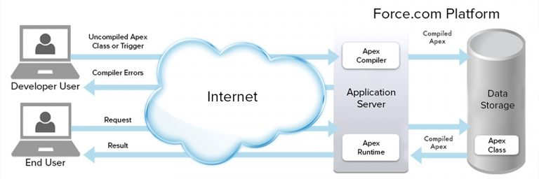

Developer Console In Salesforce

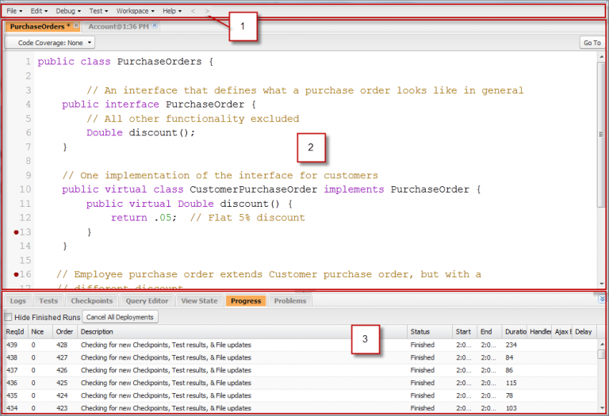

ABOUT THE PROJECT
TARGET USER & MARKET:

- People who want to avail loan on the gold owned by them.
- People who want to make extra money by the gold they own.
- Mortagage system is equally beneficial for the banks as well because if the customer or the person is not able to pay the loan then the bank can keep the invested golsd with them.

OVERVIEW

“GOLDVISOR” is a platform where we provide loan against gold deposited.
It is a centralized platform which can be used by different organizations to store, fetch and protect information.
It includes infomations related to the customer,loan, employee and branch.
It even displays the previous and updated rates of gold via graphical represtation.
It also maintains the integrity of the customer's info.

CONCLUSION
- We have acquired the knowledge of salesforce, apex ,Visualforce with practical skills.

- We have Learnt how to interact with database.

- We have Learnt so much about the banking Industry.

- We have learnt how to deal with live projects.

- We have learn to work with Lightning Framework.

- Importance of Storing data on cloud.

- How Data is Stored on cloud.

- How can we store data in bulk upon cloud usin dataloader.

- GoldVisor can be very helpful for Gold loan banks in future.

- Goldvisor is a Web application so it does not require any other platforms to work upon.

LITERATURE SURVEY
- Salesforce Developer Guide

- Trailhead.com

- Salesforce TutorialKart

- Visualforce Developer Guide

- SBI corporate website

- Lightning Designing System

- Muthoot Finance

- Mannapuram Gold Loan

